Lecture no 1



**Example of Limit:**

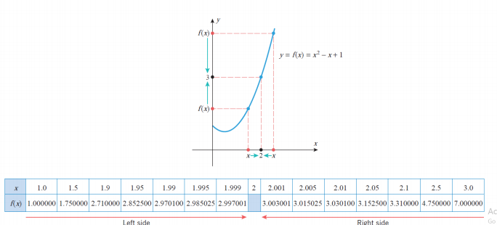

Example of two sided limits:

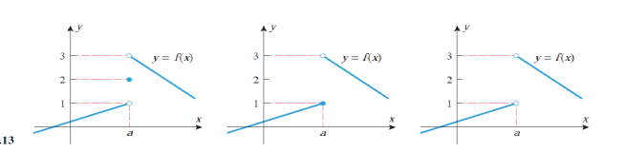

Example:

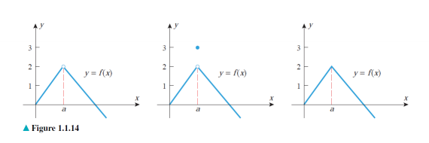

Example of Infinite Limits:

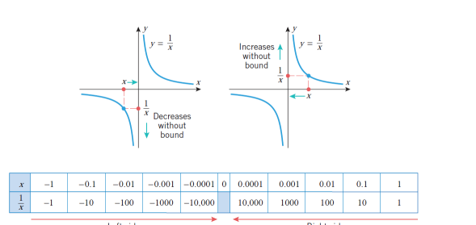

Continuity:

